Testing Policy Document

Stacks on Stacks

Group Members:

Akua Afrane-Okese U15019773

Linda Zwane U14199468

Ntiko Mathaba U14012503

Tyler Matthews U15302424

Contents

Introduction 3

Purpose of Document 3

Purpose of Policy 3

Mission of Testing 3

Description of the test process 3

1. Prepare for test-driven development 3

Testing Tools 4

Levels of Testing and approaches used 5

2. Write Tests 6

2.1. Unit Testing 6

2.2. Instrumented Tests 13

2.3. Repeat until all features are correctly implemented 15

2.4. Accomplish test coverage 15

3. Test cases 15

4. References 15

## Introduction

### Purpose of Document

The purpose of this document is to provide a clear statement as to the testing process for software and to outline who is responsible for which parts of that process.

### Purpose of Policy

Testing is needed in order to detect potential problems within the software as early as possible, so that they can be corrected at minimum cost.

### Mission of Testing

* To strive towards perfection in the delivery of a software product which is as defect-free as possible.
* To constantly seek better methods and processes to help insure the delivery of a quality product.
* To fulfil software requirements as stipulated in the systems requirement documentation

### Description of the test process

For testing, the focus is on making sure functions run with the different possible cases. We have decided to use Test-Driven Development. Test driven development allows us to continuously test our code throughout the development cycle of our application. Tests are performed immediately after coding the classes to mitigate errors in advance together with each time an update is made. The following are the steps that we have used for our testing process:

## 1. Prepare for test-driven development

The skeleton code for the class is generated. The team member that is in charge of testing the class needs to fully understand the classes implementation. A UML diagram will aid the team member in understanding the class.

### Testing Tools

* JUnit Testing Framework (4.12)

JUnit allows for programmers to work on applications and their testing from one platform, which allows access to package private elements within the application. It provides annotations to easily distinguish between the application and testing

The statement to include its functionality is: testImplementation 'junit:junit:4.12**'** (see in Figure 1).To use JUnit, its statement needs to be included in the Android Studio project gradle, in the section called dependency.

* Mockito (1.10.9)

Mockito is used to mock interfaces so that dummy functionalities (or functionality) can be added to a mock interface that can be used in unit testing so that classes can be tested on their own, without testing dependencies to verify that the code being tested works without dependencies. It also caters for resources that are not actually available.

The statement to include its functionality is: testImplementation 'org.mockito:mockito-core:1.10.19' (see in Figure 1). To include its functionality, its statement needs to be included in the Android Studio project gradle, in the dependency section.

* Espresso (3.0.2)

Espresso is used to create automated user interface tests. It is based on JUnit, thus easy to include. Espresso also needs to be stated in the dependency section. Its statement being: androidTestImplementation 'com.android.support.test.espresso:espresso-core:3.0.2' (see in Figure 1).

* Robolectric (3.0)

Robolectric also needs to be stated in the dependency section. Here is its statement: androidTestImplementation 'org.robolectric:robolectric:3.0'. Not all areas need to be mocked (use mocking frameworks like Mockito). Robolectric lets you run your tests on your workstation, or on your Continuous Integration environment in a regular JVM, without an emulator.

* AndroidJUnitRunner

“Instrumentation tests are used for testing Android Frameworks such as UI, SharedPreferences and so on. Since they are for Android Framework they are run on a device or an emulator” (Ajesh, 2018).

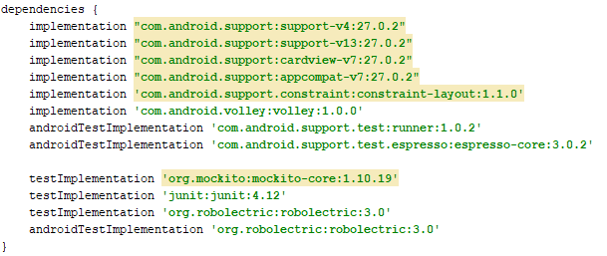

Figure 1.1: StacksonStacks Part 1 Project Gradle in Android Studio

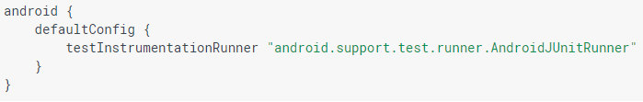

Figure 1.2: StacksonStacks Part 2 Project Gradle in Android Studio

### Levels of Testing and approaches used

The different levels of testing promote mitigation and quality risk as early as possible.

|  |  |  |  |
| --- | --- | --- | --- |
| **Level** | **Owner** | **Objective** | **Key Areas of Testing** |
| Unit | Developer | * Detect defective units of code * Reduce the risk of unit failure in production | * Functionality * Resource Utilization |
| Integration | Developer | * Detect defects in unit interfaces * Reduce risk of dataflow and workflow failures in production | * Functionality * Unit interoperability and compatibility * Performance |
| Acceptance | Business owner | * Detect in user workflows * Demonstrate that the product works as expected * Ensure that all the requirements are met | * Functionality * Operational processes |

## 2. Write Tests

### 2.1. Unit Testing

The following scenarios are tested on (unit testing):

1. Device Scanning
2. Bluetooth Connectivity and Bluetooth Initialization
3. Device Control
4. Gatt Attributes
5. Login
6. Device Scanning

* Testing if it is scanning only after creation (Expected Result: False)
* Testing if scanning after creation and instructed to scan for BLE device(Expected Result: True)
* Testing if device continues scanning after instructed to twice (Expected Result: True)
* Testing if device is scanning after instructed to start and then stop scanning(Expected Result: False)
* Testing to verify if device is scanning a custom timeout period(Expected Result:False)

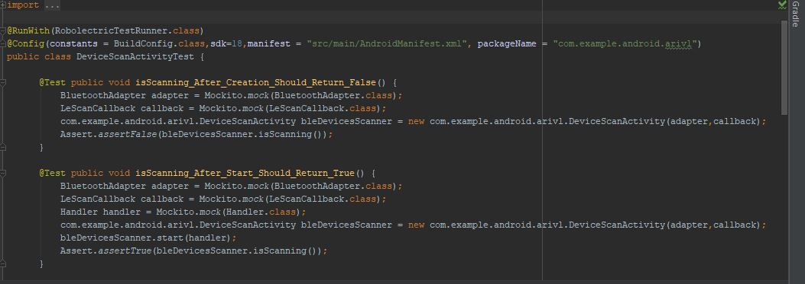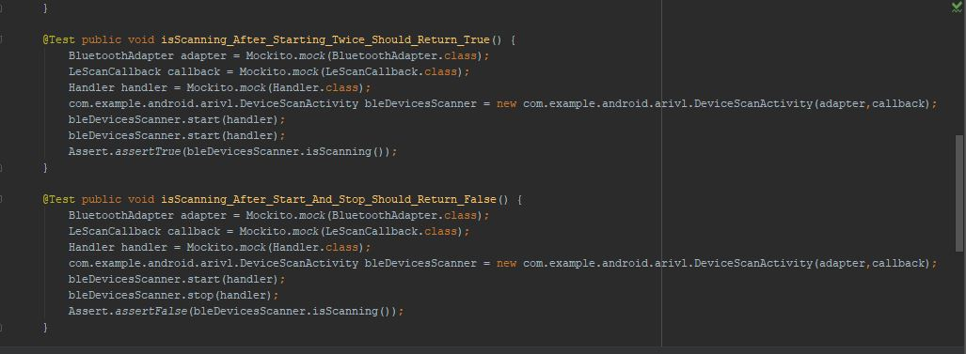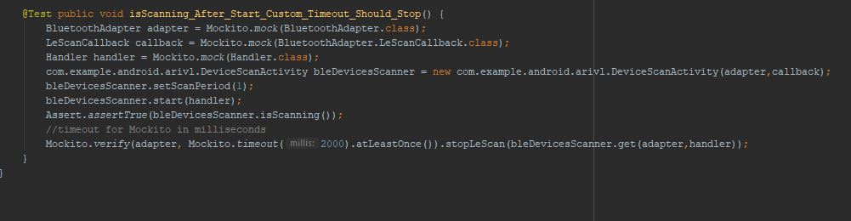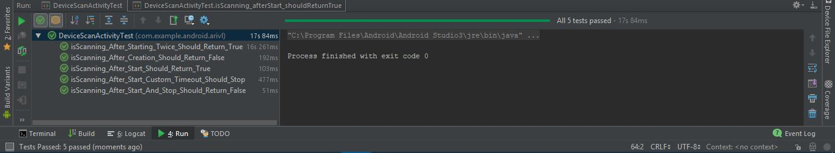

2. Device Connectivity

- testing if connection is established (Expected Result : True)

- testing if connection is not established (Expected Result: False)

- testing if bluetooth initialized (Expected Result: True)

- testing if bluetooth not initialized (Expected Result: False)

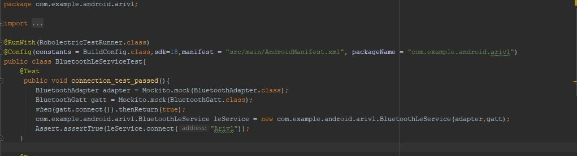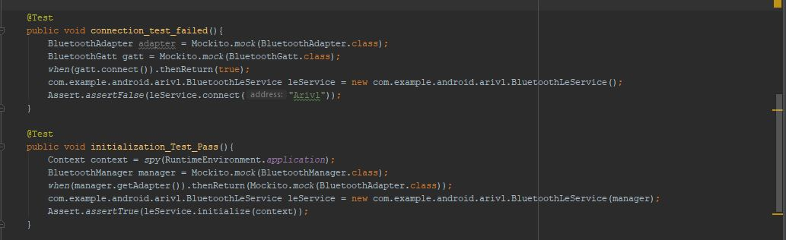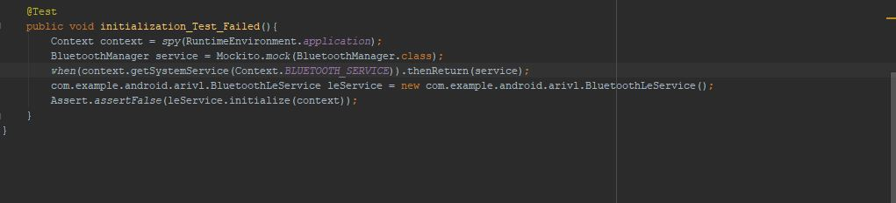

(Above are images of the code for the test cases)

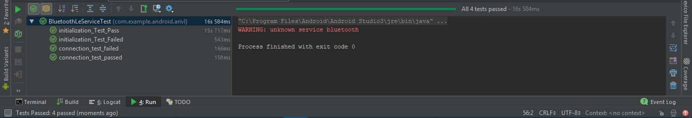

(Above is a screenshot of all 4 Test Cases Passing for Connectivity)

3. Device Control

* To ensure Intent Filter updates (Expected Result : NotNull)
* To ensure the display field is updated (Expected Result : NotNull)

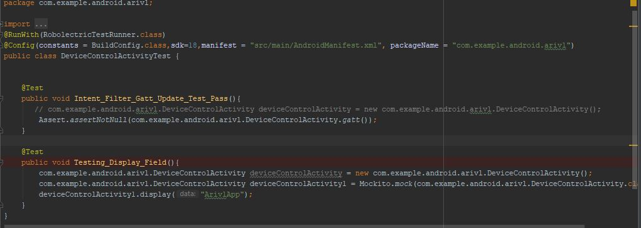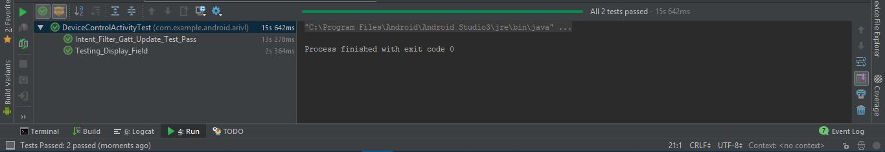

4. Gatt Attributes

* To ensure read/write permissions (Expected Result : NotNull)
* To ensure sufficient encryption and authentication (Expected Result : NotNull)
* To ensure request permissions (Expected Result : NotNull)
* 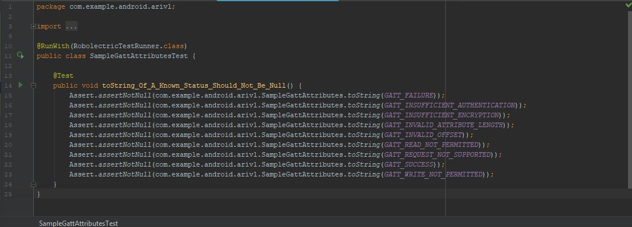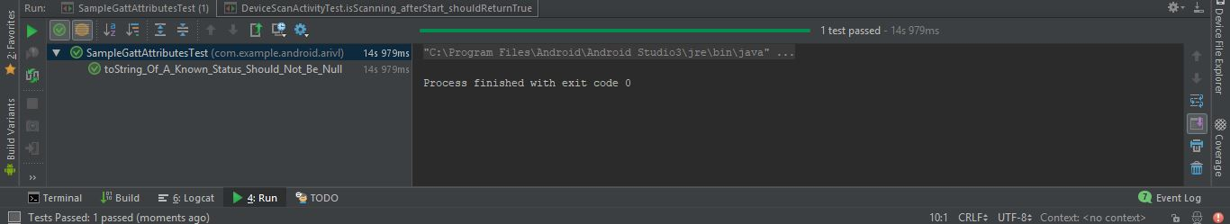

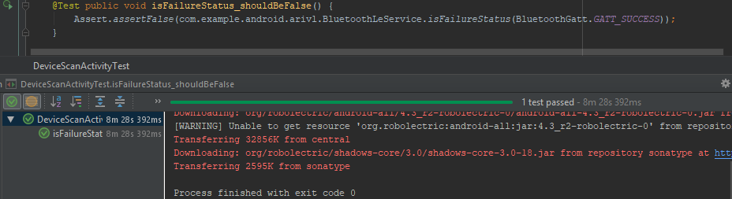

1. These are the following test cases that are going to be conducted to test the login functionality:

|  |  |
| --- | --- |
| **Steps** | **Expected Results** |
| Enter a valid username and password. Click Login button | The application should display the Splash Screen |
| Logout. Enter a valid username and an invalid password. Click the Login button. | The application should display an error message and reopen the Login page |
| Enter an invalid username and an invalid password. Click Login button | The application should display an error message and reopen the Login page |
| Leave the username and password blank. Click Login button. | The application should display an error message and reopen the Login page |

The following are the possible combinations input values the user might enter and click on the login button. A test can only be deemed passed if the expected result matches the actual result. The results are as follows:

|  |  |  |  |
| --- | --- | --- | --- |
| **Verify username and password** | **Expected Result** | **Actual Result** | **Home Page / Error** |
| Valid username, Valid Password | Success | Success | Home Page |
| Valid username, Invalid Password | Fail | Fail | Error |
| Valid username, Blank | Fail | Fail | Error |
| Invalid username, Valid Password | Fail | Fail | Error |
| Invalid username, Invalid Password | Fail | Fail | Error |
| Blank, Invalid Password | Fail | Fail | Error |
| Blank, Valid Password | Fail | Fail | Error |
| Blank, Invalid Password | Fail | Fail | Error |
| Blank, Blank | Fail | Fail | Error |

The above table shows us the different combinations that the user might enter when trying to login into the Arivl application and the result of the input combination. It shows us that there is only one case that the user will be able to login into the Arivl application and that is when the user has entered a valid username and valid password.

Down below is a screenshot of the different tests we have conducted using Junits Automated Unit Testing framework

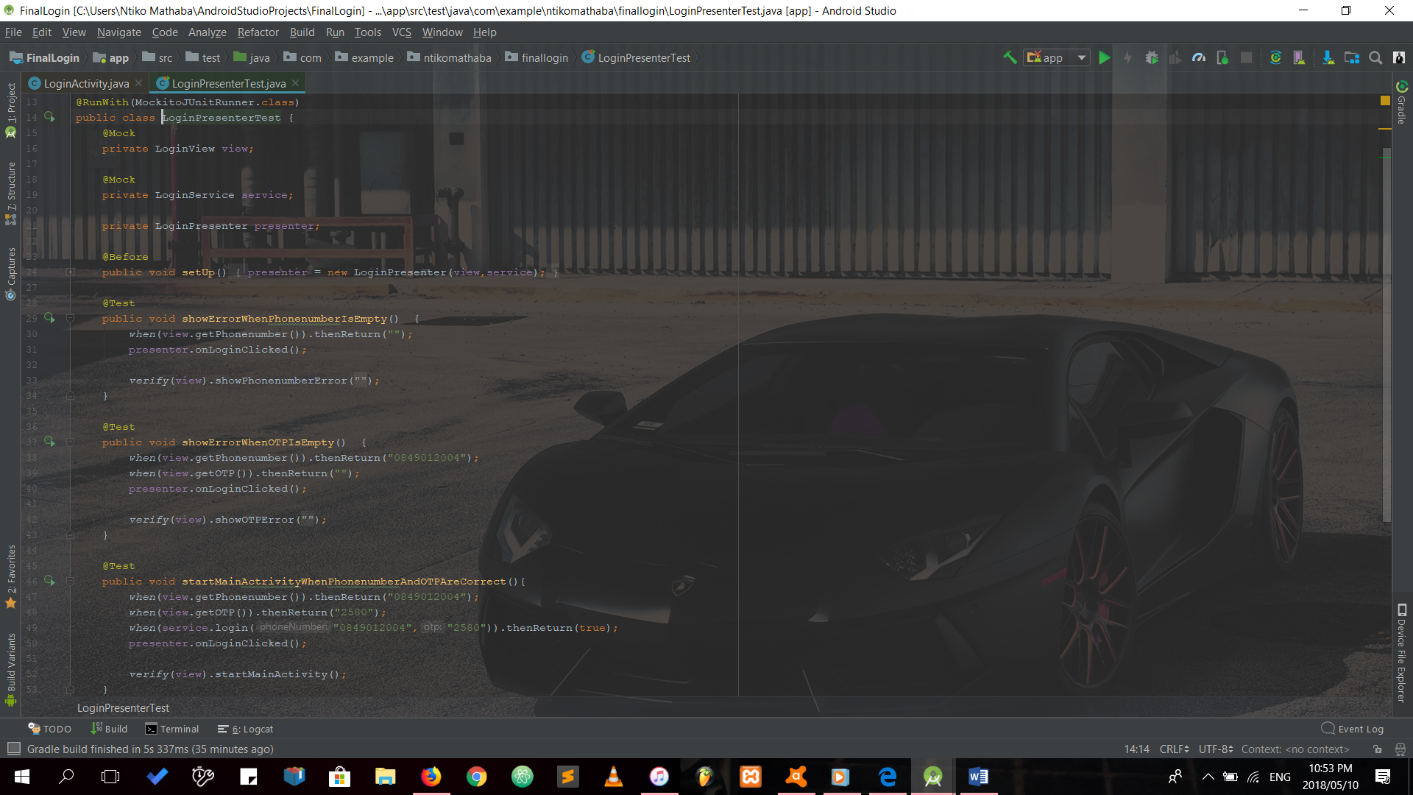

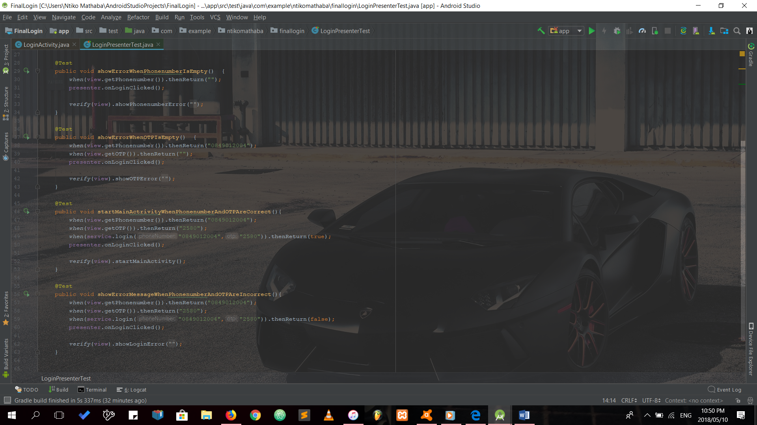

Down below is a screen shot of the tests that we have written and they have passed. They have been sorted according to time duration. It is evident that the test that takes the longest is when the user enters an invalid username and invalid password.

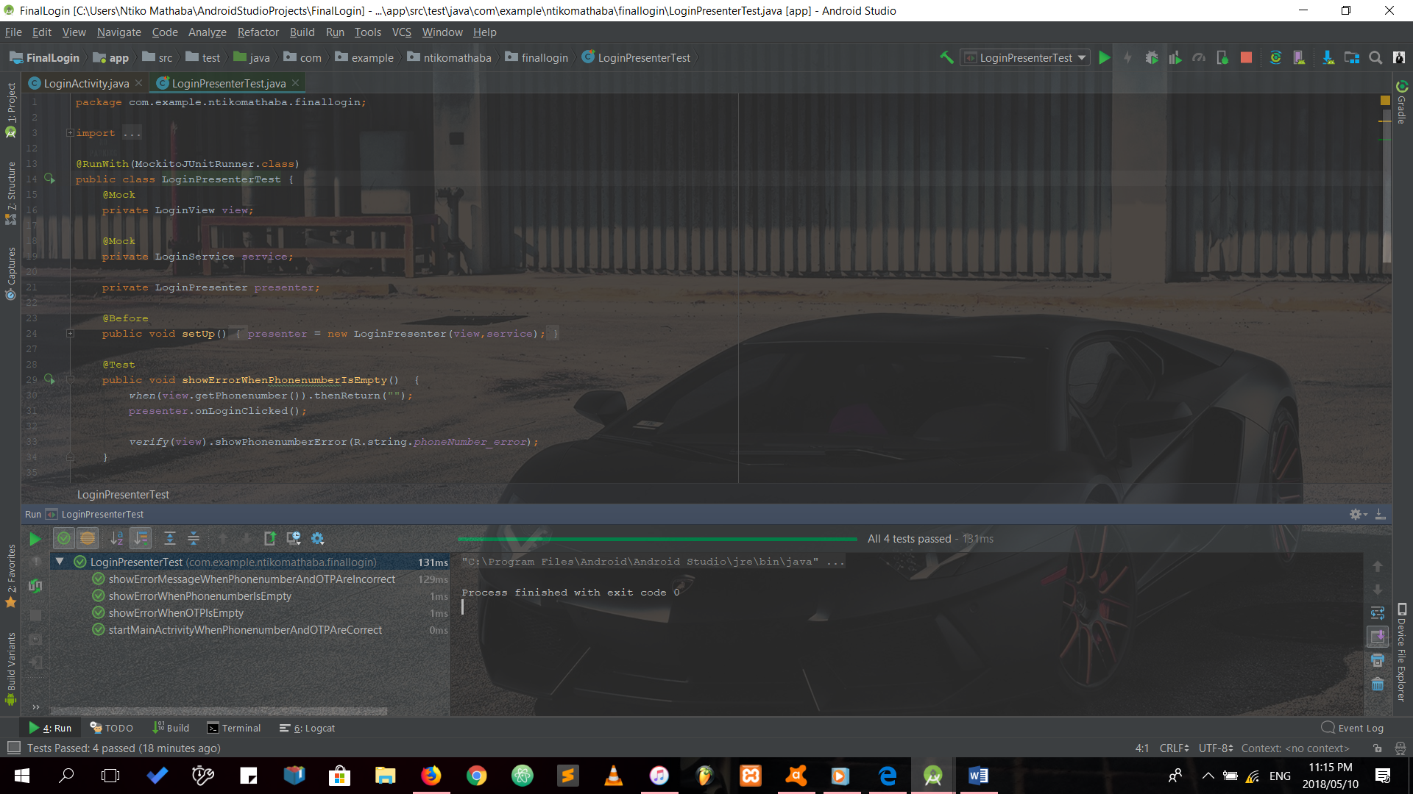

### 2.2. Instrumented Tests

“Under normal circumstances your application cannot control the life cycle events and the user drives the application” (Vogella, 2017). Using instrumentation, you can control these events through your test code. “An instrumentation-based test class allows you to send key events (or touch events) to the application under test” ” (Vogella, 2017).

1. Splash Page

2. Login Page

1. Splash Page

isOnScreen ()

- verify the content text of btn_next (“next” button) displays correctly (Expected Result: True)

- verify the display of the activity of the splash pages (Expected Result: True)

- verify the display of the layout dots on the splash pages (Expected Result: True)

- verify the content text of btn_skip (“skip” button) displays correctly (Expected Result: True)

MessageSentToMessageActivity()

- verify that after the first activity page btn_skip is enabled (Expected Result: True)

verifySkipDisabled ()

- verify that btn_skip is disabled (Expected Result: True)

- verify that btn_next is enabled and click/ tap functionality works (Expected Result: True)

- verify that btn_next changes all activity pages (Expected Result: True)

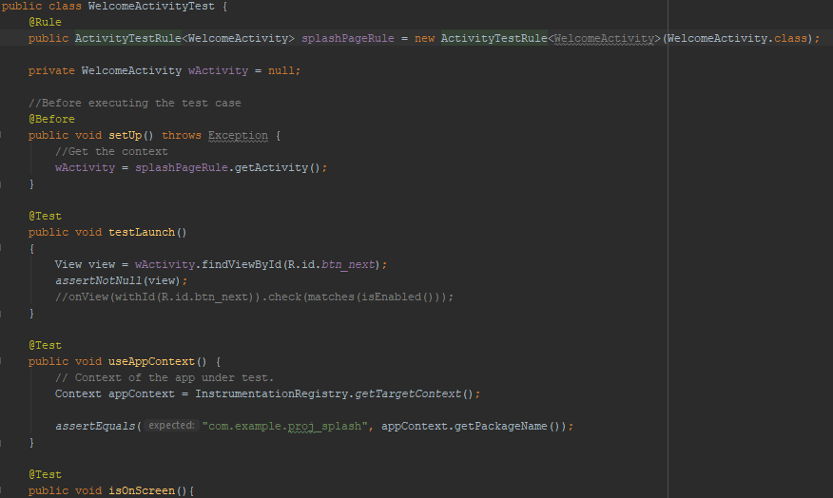

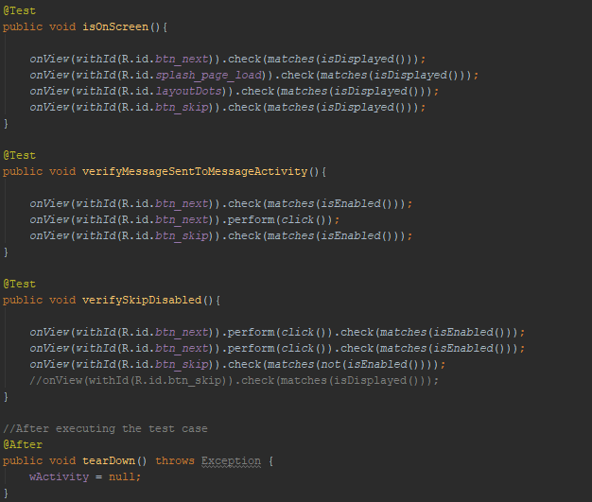

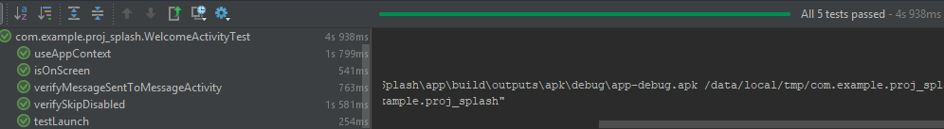

2. Login Page

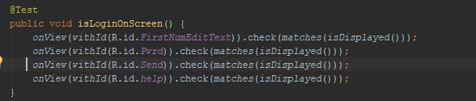

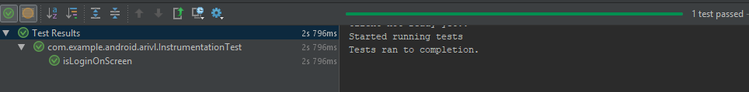

### 2.3. Repeat until all features are correctly implemented

Iterate through step 2 and step 3 until all the features are implemented and all the tests pass.

### 2.4. Accomplish test coverage

Android Studios allows us to export the results of our tests into an html file. Below is a screen shot of our test coverage:

## 3. Test cases

All the tests can be found on Github: https://github.com/devawa/StacksOnStacks/tree/master/Android_Dev/Tests

## 4. References

Ajesh. 2018. Android Testing Part 1: Espresso Basics. [Online]. Available: https://medium.com/mindorks/android-testing-part-1-espresso-basics-7219b86c862b [1 October 2018].

Android Developers. [n.d]. Espresso. [Online]. Available: https://developer.android.com/training/testing/espresso/ [Accessed 18 July 2018].

Robolectric. [n.d]. Robolectric Test-Drive your Android Code. [Online]. Available: http://robolectric.org/ [Accessed 19 July 2018].

Tutorialspoint. [n.d]. Mockito Tutorial. [Online]. Available: https://www.tutorialspoint.com/mockito/ [Accessed 19 July 2018].

Vogella. 2017. Developing Android unit and instrumentation tests – Tutorial. [Online]. Available: http://www.vogella.com/tutorials/AndroidTesting/article.html#androidtesting_instrumentation [1 October 2018].